Level Designs and puzzles:

Tutorial Levels

As previously stated the tutorial level/ sequence will be a series of level that introduce the player to the basic mechanics; push, pull, press (note according to changes by Thomas, should be Pick up, Put down and Press)

Possible tutorial sequence:

Opens up on a pile of robots/ robot parts Gar. being on top of or near the edge of the pile deactivated. Bird flies down and lands on Gar and he activates and slowly stands, the bird flies off into the darkness and a light flickers on revealing the bird by a door at the far end, the door is blocked by a box with space at either side for Gar to move the box.

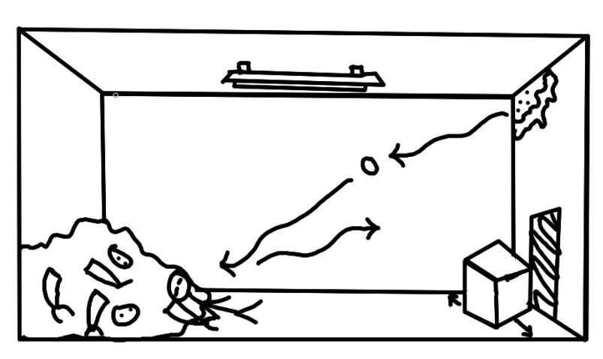

Entering the next room the bird once more flies to the door on the far side, lights flicker on revealing a (working) lever on the wall with a wire running to the door pulling/ activating the lever opens the door on the far side, allowing Gar to proceed.

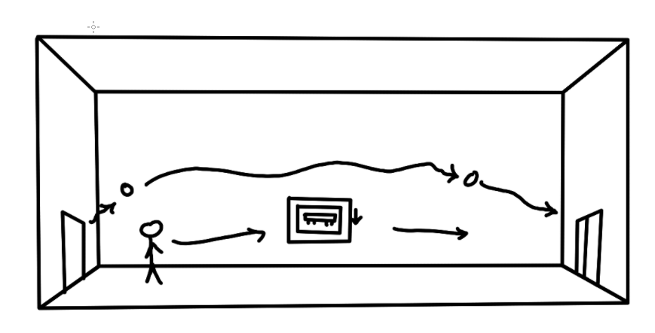

The next room contains a multitude of boxes in a special arrangement \*as well as one weighted pressure plate next to a broken lever a wire runs from the plate to the lever. The player must move the boxes in a specific way in order to proceed then pick up one of the boxes to place on the pressure plate (or stand on the plate) giving power to the lever, the lever still requires Gar remove one of his arms to pull it however. Pulling the lever opens the door leading either outside or further into the factory/building/facility ending the demo/tutorial.

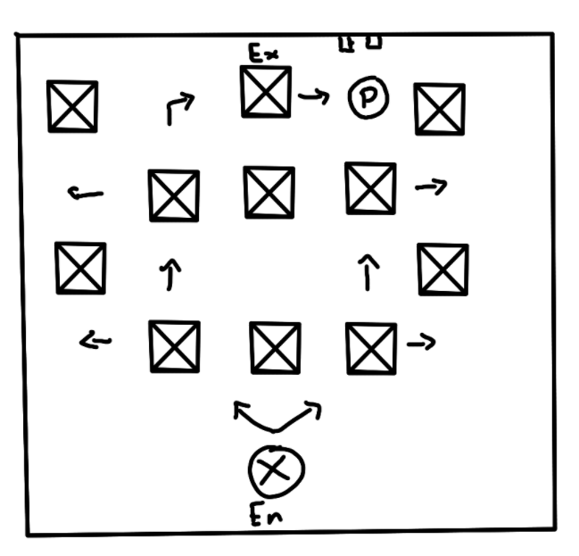

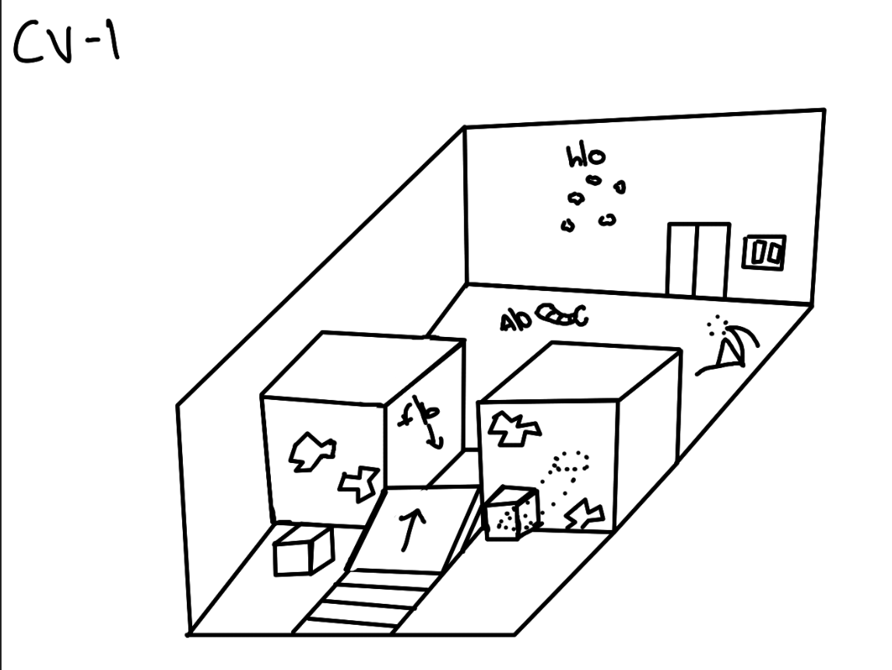

See-saw:

Level separated into two sections/ halves first half has a coupole decoy boxes and the see/saw in the middle as well as a ramp leading up a mezzanine, second half has a weighted button and the exit with a door connecting the two. Player must drop its arms on the lowered part of the seesaw then roll up and off the mezzanine in order to launch the arms through a hole in the fence/ wall between the two and onto the weighted button on the other side opening the door between the two rooms.

Bird call:

Room contains three levers(maybe broken) with flashing lights at their base, the bird guide perches near the levers and begins singing a song hinting at the order the lever should be pulled in eg 312, 231, 132 (could have player pull lever repeatedly eg 1132, or go through multiple sequences each one opening the exit door a bit more than the last) which opens the exit door.

DDR

Continuing to make use of the concept in Bird Call, the room contains a set of weighted plates each with their own distinct light and sound when pressed. Bird guide sings a tune which the player must repeat by stepping on the weighted plates in order.

London Bridge

Set outside, open area with a raised bridge broken on both sides to allow for passage through. Large amounts of snow on either side with no clear control box for lowering the bridge. Bird guide hovers around a protrusion in the snow, approaching it reveals that the protrusion can be picked up. The protrusion is in fact a box beneath the snow hiding the lever that controls the bridge pulling it lowers the bridge and allows for safe passage.

Pushback

Set outside, a massive amount of snow is held up by a canopy the lever for which is on the other side. Bird guide hovers around the canopy, but pulling the liver and lowering the canopy releases enough snow that sweeps GAR away. Player must pull the lever and quickly drop all body parts down to the torso and begin rolling towards the snow rolling on top of the snow without getting swept away eventually allowing GAR to travel up the pile of snow and out of the area.

Pushing through

Open area with alot of decoy items and a large pit of snow in the middle , snow in the very center of the pit seems to be falling down indicating the solution. Gar must enter the pit and navigate blindly through an “under snow” maze in order to reach the area below.

Unboxing

Areas split by water/river going vertically down the middle, small raft in the river to allow traversal. Raft and Gar will sink unless Gar is down to its torso on the other side are a multitude of stacked boxes about 2 or 3 high. And a box positioned in front of the exit door. Gar must roll into and knock over the top box for it to break on landing revealing either a body part or something useless like junk, snow, rats etc. To leave Gar must Knock over and Gather enough parts to pick up and move the box blocking the door.

Rat Trap\*

Room with a group of boxes in a 3 by 6 formation, a door on the other side with a missing battery (or lever with a missing battery) and a mouse hole on one side of the room. When Gar enters a rat with the battery in its mouth will run into the hole it will then be under one of the boxes (randomly selected). We could give a hint by having the box rattle slightly. Gar must pick up the first box only for the rat to disappear into a hole under the box and travel either to a random box or two boxes down and one across (in the case of boxes near the edge it would loop over). Picking up the second box will cause the rat to drop the battery and run away.

Crane Game\*

Factory floor with a control box on a mezzanine, the stairway off the mezzanine is broken and there are ditches between the entrance and the exit, there are also 2 to 4 weighted switches near the exit. Gar starts on the mezzanine and walking up to and interacting with the control box will activate a crane at the top of the building. Once in the crane view the movement controls will move the crane whilst the interact key will create a box on a conveyor belt below. Gar must pick up and place boxes to 1. Create a stairway, 2. Fill in the ditches and 3. Place enough boxes to activate the weighted switches.

Snow Storm\*

Gar steps out of a building outside where a snowstorm is raging, Camera view changes to much closer behind Gar almost just over its shoulder and the snowstorm reduces visibility to just a few feet in all directions. Gar must traverse the snowstorm solving small simple puzzles along the way with this reduces vision. The bird is key here as it will fly off into the storm towards each step of the puzzle and will guide Gar by making a sound only audible when the wind dies down intermittently. Puzzle 1 is a lever Gar must use an arm to pull to activate a bridge ahead. Puzzle 2 is an alleyway maze that Gar passes through picking up nearby boxes and placing them in the snow in key areas so they sink in and create a bridge. Puzzle is a series of broken levers Gar must pull in the right order to open a door at the end, the bird will spend very little time at each lever however flying off to the next as soon as Gar comes into view. And when Gar tries to go to the door a large patch of deep snow which Gar could sink in will be in front of the door forcing Gar down to just his torso.